Making Water Disappear

Subject: Making Water Disappear  Related Subjects:physics, geology | Grade Level(s): middle school  Length of Lesson:30 mins | Type: Inquiry / Design / Project  Keywords: compression, geology, physics, dilatancy

Lesson Overview
Students will learn about the concepts of compression and dilatancy and how they act when wet sand is squeezed. They will understand the physics of how water behaves in sand versus how it behaves on its own.

Lesson Focus
Why does water seem to disappear when it is squeezed in sand but acts differently when water by itself is squeezed? Students will answer this question and understand how the sand particles behave differently when they are wet and why the water appears to disappear.

Lesson Objective(s) | By the end of this lesson, students will…  - Understand why footprints appear dry in wet sand and the science behind it .  - Be able to make observations on the differences between squeezing water, dry sand, and wet sand.

Lesson Timing

5 minutes | Introduce the lesson and discuss background.
5 minutes | Make predictions.
15 minutes | Do the procedure and observe how the water level changes.
5 minutes | Make changes and try variations to the experiment.
5 minutes | Discuss lessons learned and clean up.

Materials | *All materials are per student since this experiment is designed to be done at home.  - 2 balloons or plastic gloves  - 2 rubber bands  - 2 plastic straws  - Sand (about two cups)  - Water  - Spoon  - Piece of paper (or a funnel)  - Plastic water bottle  - Tray or bowl (optional- to catch spills)
Teacher Prep | - Test out the experiment beforehand.
Related Resources | - https://www.scientificamerican.com/article/make-water-disappear-with-the-wet-sand-effect/  - https://youtu.be/Dg3uYPvSoIs

Lesson Plan

Introduction
Introduce students to the learning goals and make connections to past and present learning experiences. Stimulate interest and prompt students to identify their own questions about the topic. This can link the lesson to real world examples, introduce associated STEM careers, and assess their prior knowledge on the topic.

Questions About the Topic
- Do you know what sand is made of? Or how sand is made?
- How do you think the sand or properties of the sand changes when it is wet?
- What do you think will happen when we squeeze the wet sand?

Real World Examples
- Walking on the beach

Procedure

- Step 1: Make a funnel with the piece of paper (or just use a funnel), and using the spoon add the dry sand into the plastic water bottle until the water bottle is almost full.
- Step 2: Inflate one of the balloons and stretch its neck over the top of the mouth of the water bottle.
- Step 3: Turn the water bottle over and pour the sand into the balloon.
- Step 4: Release the remaining air in the balloon.
- Step 5: Add water to the sand in the balloon until the sand is saturated. (You can use the same method with the water bottle you used to get the sand in the balloon.)
- Step 6: Insert a straw into the sand in the balloon and secure it in place by wrapping a rubber band around the straw and the surrounding neck of the balloon. (see picture below)
- Step 7: Fill the second balloon with water.
- Step 8: Insert a straw into the second balloon so that it is in the water, and secure it in place by wrapping a rubber band around the straw and the surrounding neck of the balloon.
- Step 9: Hold the balloon filled with water at its neck and add water to the straw until the water comes about halfway up the straw.
- Step 10: Squeeze the balloon softly and observe what happens to the water level in the straw.
- Step 11: Hold the balloon filled with wet sand at its neck and add water to the straw until the water comes up about halfway to the straw.
- Step 12: Squeeze the balloon softly and observe what happens to the water level in the straw.
- Step 13: Release the balloon and observe what happens to the water level now.
- Step 14: Clean up and discuss lessons learned.
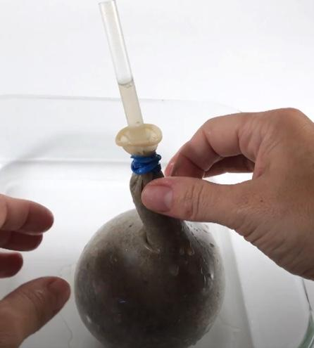

Wrap-up
- What did you learn in this experiment?
- Were your observations different than what you expected? How?
- What could you try differently next time?

Cleanup Considerations
Have a towel handy to clean up any water or sand spills that might have occured.

Lesson Background for Teachers

Suggested Real-World STEM Connections


- Name: Sir Mokshagundam Visvesvaraya
- Years: 1860-1962
- Quick Facts:
  - Indian civil engineer
  - “Chief architect behind the construction of the Krishna Raja Sagara dam in Mandya which helped to convert the surrounding barren lands into fertile grounds for farming”
  - “He was awarded with independent India’s greatest honor, The Bharat Ratna in 1955 for his relentless work in the fields of engineering and education.”
- Source(s):
  - 1. http://www.thefamouspeople.com/profiles/m-visvesvaraya-5290.php

Lesson Variations and Options
- Try only partially wetting the sand so that it is not saturated. Does the water disappear? Do you notice any changes?
- What other materials could we use to make water disappear?
- Try doing the experiment in the water bottle instead of in a balloon. Is it harder to press the sand?
- Try filling a balloon with dry sand and filling another balloon with wet sand. Squeeze both of them and observe how they feel differently. Why is this?

Explanation
Have you ever noticed that when you walk on the beach your footprints in the wet sand appear dry? Why does the water disappear when wet sand is compressed? When water is poured onto water, it seems to disappear into the sand. What is happening is that it is being absorbed into tiny pores between the sand grains. When we add enough water to saturate the sand, all of the pores are filled and no more water can be added to the sand. If any more water is added it will just sit at the top of the sand but will not be absorbed by it. When you squeeze the sand you might expect the water to come out of it, like it would if you squeezed a wet sponge, but this is not the case. Instead, something called dilatancy happens. Dilatancy means that a material expands when it is squeezed. So when the wet sand is squeezed, the pressure causes the sand particles to move apart from each other. This creates extra gaps where the water can go. Therefore the water appears to disappear into the sand by filling these spaces made by squeezing the sand. When you stop squeezing and the pressure is removed, the particles move back closer to each other and there is less space between them. Then the water level goes back to normal and reappears because it is pushed out of the gaps.

Key Concepts and Vocabulary
- Dilatancy = a material expands when you squeeze it
- Compression = squeezing something
- Saturated = holding as much water as it possibly can

Safety Notes
- Pour out the water from the balloons before disposing of them.

Standards

NGSS PEs
5-PS1-3: Make observations and measurements to identify materials based on their properties
NGSS SEPs  List the Practices actively done in this lesson | NGSS DCIs  PS1.A: Structure and properties of matter | NGSS CCCs  Scale, proportion, and quantity

